**Introducing Hotel Hub**

Project Deliverable 01

Hotel Hub is a dynamic hotel management company operating across several major cities globally, including New York, London, Paris, Tokyo, and Sydney. Established in 2010, Hotel Hub manages a network of premium hotels, each aimed at providing exceptional hospitality services to a diverse client. With its headquarters located in London, Hotel Hub ensures efficient operation through a centralized database management system that integrates all aspects of hotel management. HotelHub’s database includes Hotel, Room, Guest, Reservation, Employee, Service, Payment, Review, Location, Manager, Housekeeping, Maintenance, Event, Promotion, Supplier, and Inventory. Each Hotel is managed by a manager and is segmented into various Rooms, each with unique characteristics like room type, price, and availability. Guests can make Reservations directly through HotelHub’s user-friendly website or mobile application, choosing their preferred Room and dates. For each Reservation, different Services such as spa treatments, dining reservations, and transportation bookings can be added, enhancing the guest experience. Employees are crucial to HotelHub's operations, with roles ranging from front desk agents to housekeeping and maintenance staff. The database handles Employee schedules, payroll, and performance reviews to streamline human resources processes. Payments for services and accommodations are processed through the system, offering multiple options such as credit card, debit card, and direct bank transfers. HotelHub’s database also manages Guest Reviews, which are vital for maintaining service quality and reputation management. Each hotel location can host Events, from conferences to weddings, requiring management of schedules, guest lists, and service provisions. Promotions and discounts are offered to guests through the database, tailored to guest preferences and booking history. The Inventory and Supplier ensure that each hotel is well-stocked with necessary items, from linens to toiletries, and integrated with external suppliers for seamless supply chain management. HotelHub's commitment to excellence is reflected in its meticulous data management, which ensures efficient operations and superior guest satisfaction across its global network.

**Entity Relationship Diagram(ERD)**

Project Deliverable 02

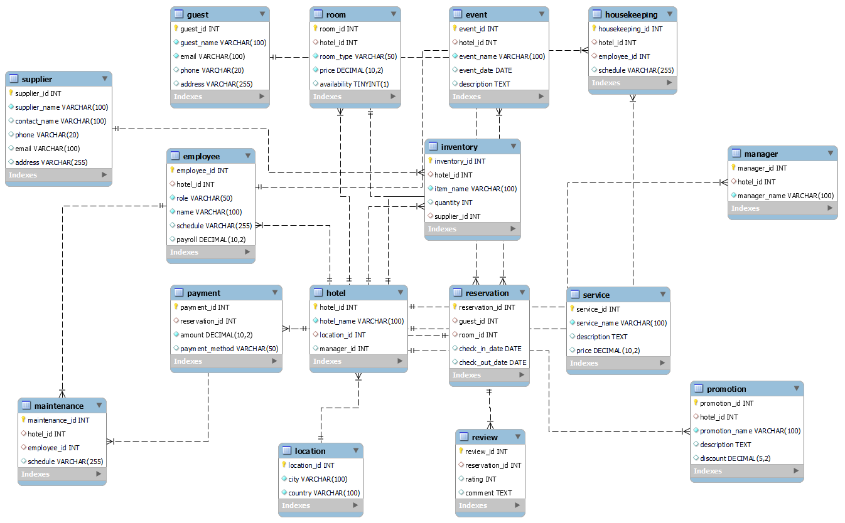

**SQL Tables and Complex Queries**

Project Deliverable 03

CREATE TABLE Location (

location_id INT PRIMARY KEY,

city VARCHAR(100) NOT NULL,

country VARCHAR(100) NOT NULL

);

CREATE TABLE Hotel (

hotel_id INT PRIMARY KEY,

hotel_name VARCHAR(100) NOT NULL,

location_id INT,

manager_id INT,

FOREIGN KEY (location_id) REFERENCES Location(location_id)

);

CREATE TABLE Manager (

manager_id INT PRIMARY KEY,

hotel_id INT,

manager_name VARCHAR(100) NOT NULL,

FOREIGN KEY (hotel_id) REFERENCES Hotel(hotel_id)

);

CREATE TABLE Room (

room_id INT PRIMARY KEY,

hotel_id INT,

room_type VARCHAR(50) NOT NULL,

price DECIMAL(10, 2) NOT NULL,

availability BOOLEAN,

FOREIGN KEY (hotel_id) REFERENCES Hotel(hotel_id)

);

CREATE TABLE Guest (

guest_id INT PRIMARY KEY,

guest_name VARCHAR(100) NOT NULL,

email VARCHAR(100) UNIQUE NOT NULL,

phone VARCHAR(20),

address VARCHAR(255)

);

CREATE TABLE Employee (

employee_id INT PRIMARY KEY,

hotel_id INT,

role VARCHAR(50) NOT NULL,

name VARCHAR(100) NOT NULL,

schedule VARCHAR(255),

payroll DECIMAL(10, 2),

FOREIGN KEY (hotel_id) REFERENCES Hotel(hotel_id)

);

CREATE TABLE Service (

service_id INT PRIMARY KEY,

service_name VARCHAR(100) NOT NULL,

description TEXT,

price DECIMAL(10, 2)

);

CREATE TABLE Reservation (

reservation_id INT PRIMARY KEY,

guest_id INT,

room_id INT,

check_in_date DATE,

check_out_date DATE,

FOREIGN KEY (guest_id) REFERENCES Guest(guest_id),

FOREIGN KEY (room_id) REFERENCES Room(room_id)

);

CREATE TABLE Payment (

payment_id INT PRIMARY KEY,

reservation_id INT,

amount DECIMAL(10, 2) NOT NULL,

payment_method VARCHAR(50),

FOREIGN KEY (reservation_id) REFERENCES Reservation(reservation_id)

);

CREATE TABLE Review (

review_id INT PRIMARY KEY,

reservation_id INT,

rating INT,

comment TEXT,

FOREIGN KEY (reservation_id) REFERENCES Reservation(reservation_id)

);

CREATE TABLE Housekeeping (

housekeeping_id INT PRIMARY KEY,

hotel_id INT,

employee_id INT,

schedule VARCHAR(255),

FOREIGN KEY (hotel_id) REFERENCES Hotel(hotel_id),

FOREIGN KEY (employee_id) REFERENCES Employee(employee_id)

);

CREATE TABLE Maintenance (

maintenance_id INT PRIMARY KEY,

hotel_id INT,

employee_id INT,

schedule VARCHAR(255),

FOREIGN KEY (hotel_id) REFERENCES Hotel(hotel_id),

FOREIGN KEY (employee_id) REFERENCES Employee(employee_id)

);

CREATE TABLE Event (

event_id INT PRIMARY KEY,

hotel_id INT,

event_name VARCHAR(100) NOT NULL,

event_date DATE,

description TEXT,

FOREIGN KEY (hotel_id) REFERENCES Hotel(hotel_id)

);

CREATE TABLE Promotion (

promotion_id INT PRIMARY KEY,

hotel_id INT,

promotion_name VARCHAR(100) NOT NULL,

description TEXT,

discount DECIMAL(5, 2),

FOREIGN KEY (hotel_id) REFERENCES Hotel(hotel_id)

);

CREATE TABLE Supplier (

supplier_id INT PRIMARY KEY,

supplier_name VARCHAR(100) NOT NULL,

contact_name VARCHAR(100),

phone VARCHAR(20),

email VARCHAR(100),

address VARCHAR(255)

);

CREATE TABLE Inventory (

inventory_id INT PRIMARY KEY,

hotel_id INT,

item_name VARCHAR(100) NOT NULL,

quantity INT,

supplier_id INT,

FOREIGN KEY (hotel_id) REFERENCES Hotel(hotel_id),

FOREIGN KEY (supplier_id) REFERENCES Supplier(supplier_id)

);

# **Insert Data**

INSERT INTO Location (location_id, city, country) VALUES

(1, 'New York', 'USA'),

(2, 'London', 'UK'),

(3, 'Paris', 'France'),

(4, 'Tokyo', 'Japan'),

(5, 'Sydney', 'Australia');

INSERT INTO Hotel (hotel_id, hotel_name, location_id, manager_id) VALUES

(1, 'Hotel NY', 1, 1),

(2, 'Hotel London', 2, 2),

(3, 'Hotel Paris', 3, 3),

(4, 'Hotel Tokyo', 4, 4),

(5, 'Hotel Sydney', 5, 5);

INSERT INTO Manager (manager_id, hotel_id, manager_name) VALUES

(1, 1, 'John Smith'),

(2, 2, 'Emma Johnson'),

(3, 3, 'Michael Brown'),

(4, 4, 'Sato Yamada'),

(5, 5, 'Sophie Wilson');

INSERT INTO Room (room_id, hotel_id, room_type, price, availability) VALUES

(101, 1, 'Standard', 100.00, true),

(102, 1, 'Deluxe', 150.00, true);

INSERT INTO Guest (guest_id, guest_name, email, phone, address) VALUES

(1, 'Alice Johnson', 'alice@example.com', '+1234567890', '123 Main St, New York'),

(2, 'Bob Smith', 'bob@example.com', '+1987654321', '456 Elm St, London');

INSERT INTO Employee (employee_id, hotel_id, role, name, schedule, payroll) VALUES

(1, 1, 'Front Desk Agent', 'Emily White', 'Mon-Fri 9am-5pm', 3000.00),

(2, 1, 'Housekeeper', 'James Brown', 'Mon-Sat 8am-4pm', 2500.00);

INSERT INTO Service (service_id, service_name, description, price) VALUES

(1, 'Spa Treatment', 'Relaxing massage and spa services', 80.00),

(2, 'Fine Dining', 'Gourmet meals and dining experience', 120.00);

INSERT INTO Reservation (reservation_id, guest_id, room_id, check_in_date, check_out_date) VALUES

(1001, 1, 101, '2024-05-01', '2024-05-05'),

(1002, 2, 102, '2024-06-10', '2024-06-15');

INSERT INTO Payment (payment_id, reservation_id, amount, payment_method) VALUES

(5001, 1001, 400.00, 'Credit Card'),

(5002, 1002, 750.00, 'Debit Card');

INSERT INTO Review (review_id, reservation_id, rating, comment) VALUES

(2001, 1001, 5, 'Excellent stay, wonderful service!'),

(2002, 1002, 4, 'Great experience overall, lovely room.');

INSERT INTO Promotion (promotion_id, hotel_id, promotion_name, description, discount) VALUES

(50001, 1, 'Summer Special', 'Enjoy 20% off on all room bookings', 20.00),

(50002, 2, 'Weekend Getaway', 'Book 2 nights, get the 3rd night free', 100.00);

INSERT INTO Supplier (supplier_id, supplier_name, contact_name, phone, email, address) VALUES

(1001, 'Linens Unlimited', 'Sarah Johnson', '+1234567890', 'info@linens.com', '789 Supplier St, City'),

(1002, 'Toiletries World', 'David Smith', '+1987654321', 'sales@toiletries.com', '456 Supplier Ave, Town');

INSERT INTO Housekeeping (housekeeping_id, hotel_id, employee_id, schedule) VALUES

(201, 1, 1, 'Mon-Sat 8am-4pm'),

(202, 2, 2, 'Mon-Fri 9am-5pm');

INSERT INTO Maintenance (maintenance_id, hotel_id, employee_id, schedule) VALUES

(301, 1, 1, 'Mon-Fri 8am-5pm'),

(302, 2, 2, 'Tue-Sat 9am-6pm');

INSERT INTO Event (event_id, hotel_id, event_name, event_date, description) VALUES

(10001, 1, 'Conference 2024', '2024-07-15', 'Annual tech conference'),

(10002, 2, 'Wedding Celebration', '2024-08-20', 'Grand wedding event');

INSERT INTO Inventory (inventory_id, hotel_id, item_name, quantity, supplier_id) VALUES

(1001, 1, 'Bed Sheets', 100, 1001),

(1002, 1, 'Towels', 200, 1001),

(1003, 2, 'Shampoo Bottles', 500, 1002);

# Quries

-- 1. Select all hotels

SELECT * FROM Hotel;

-- 2. Select all rooms in Hotel ID 1

SELECT * FROM Room WHERE hotel_id = 1;

-- 3. Select all guests from New York hotels

SELECT * FROM Guest WHERE guest_id IN (

SELECT guest_id FROM Reservation WHERE room_id IN (

SELECT room_id FROM Room WHERE hotel_id IN (

SELECT hotel_id FROM Hotel WHERE location_id = 1

)

)

);

-- 4. Select all employees in Hotel ID 2

SELECT * FROM Employee WHERE hotel_id = 2;

-- 5. Select all reservations made by guest with ID 1

SELECT * FROM Reservation WHERE guest_id = 1;

-- 6. Select all payments for reservations in Hotel ID 3

SELECT * FROM Payment WHERE reservation_id IN (

SELECT reservation_id FROM Reservation WHERE room_id IN (

SELECT room_id FROM Room WHERE hotel_id = 3

)

);

-- 7. Select all reviews for reservations in Hotel ID 4

SELECT * FROM Review WHERE reservation_id IN (

SELECT reservation_id FROM Reservation WHERE room_id IN (

SELECT room_id FROM Room WHERE hotel_id = 4

)

);

-- 8. Select all events in Hotel ID 5

SELECT * FROM Event WHERE hotel_id = 5;

-- 9. Select all promotions in Hotel ID 1

SELECT * FROM Promotion WHERE hotel_id = 1;

-- 10. Select all suppliers providing items to Hotel ID 2

SELECT * FROM Supplier WHERE supplier_id IN (

SELECT supplier_id FROM Inventory WHERE hotel_id = 2

);

-- 11. Select all available rooms in Hotel ID 3

SELECT * FROM Room WHERE hotel_id = 3 AND availability = true;

-- 12. Select the total number of guests in Hotel ID 4

SELECT COUNT(DISTINCT guest_id) AS total_guests FROM Reservation WHERE room_id IN (

SELECT room_id FROM Room WHERE hotel_id = 4

);

-- 13. Select the average rating for Hotel ID 5

SELECT AVG(rating) AS avg_rating FROM Review WHERE reservation_id IN (

SELECT reservation_id FROM Reservation WHERE room_id IN (

SELECT room_id FROM Room WHERE hotel_id = 5

)

);

-- 14. Select the total payroll for employees in Hotel ID 1

SELECT SUM(payroll) AS total_payroll FROM Employee WHERE hotel_id = 1;

-- 15. Select the most expensive room in Hotel ID 2

SELECT * FROM Room WHERE hotel_id = 2 ORDER BY price DESC LIMIT 1;

-- 16. Select the top 5 reservations with the highest payment amounts

SELECT * FROM Payment ORDER BY amount DESC LIMIT 5;

-- 17. Select all guests who stayed in Hotel ID 3 and checked out in May 2024

SELECT * FROM Guest WHERE guest_id IN (

SELECT guest_id FROM Reservation WHERE room_id IN (

SELECT room_id FROM Room WHERE hotel_id = 3

) AND check_out_date BETWEEN '2024-05-01' AND '2024-05-31'

);

-- 18. Select the total number of events happening in Hotel ID 4

SELECT COUNT(event_id) AS total_events FROM Event WHERE hotel_id = 4;

-- 19. Select the top 3 most popular services based on total revenue

SELECT Service.service_id, Service.service_name, SUM(Payment.amount) AS total_revenue

FROM Payment

JOIN Reservation ON Payment.reservation_id = Reservation.reservation_id

JOIN Room ON Reservation.room_id = Room.room_id

JOIN Service ON Service.service_id = Room.room_id -- Adjust this JOIN condition based on your schema

WHERE Room.hotel_id = 5

GROUP BY Service.service_id, Service.service_name

ORDER BY total_revenue DESC

LIMIT 3;

-- 20. Select all rooms in Hotel ID 5 with a price range between $100 and $200

SELECT * FROM Room WHERE hotel_id = 5 AND price BETWEEN 100 AND 200;